SQL ASSIGNMENT – 2

Restricting And Sorting Data

- Display ENAME, SAL, COMM of employees who earn commission and sort by Salary and Commission in descending order using column positions.

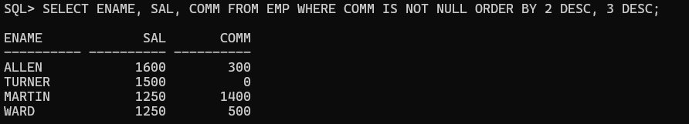

- Display all unique job codes.

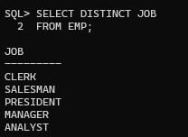

3.Display EMPNO, ENAME, JOB, HIREDATE with aliases.

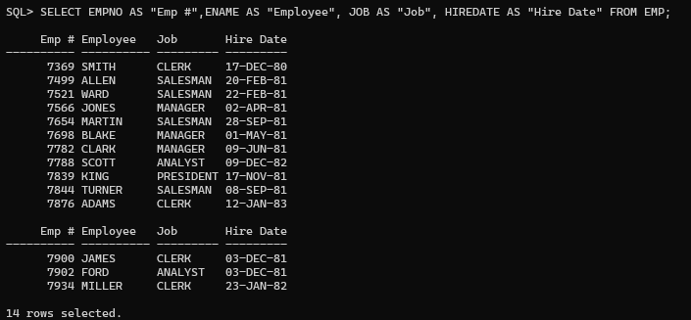

4.Display employee name concatenated with job ID.

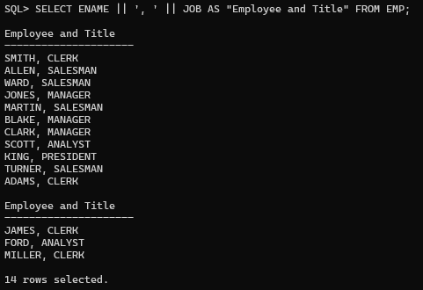

5.Display ENAME, JOB, HIREDATE, MGR separated by commas.

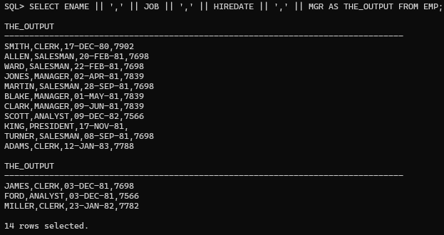

6.Display ENAME, JOB, HIREDATE for SCOTT or TURNER ordered by hiredate.

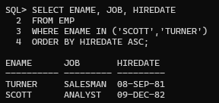

7.Display ENAME and DEPTNO for departments 20 or 30 ordered by ENAME.

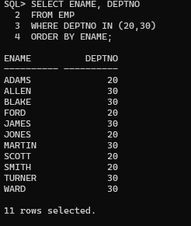

8.Display employee name and salary between 2000 and 3000 in dept 20 or 30.

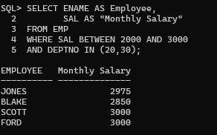

9.Display last name and hire date of employees hired in 1981.

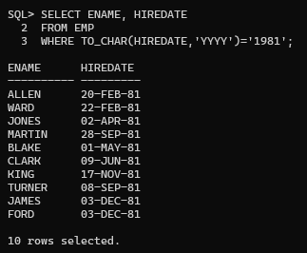

- Prompt user for salary.

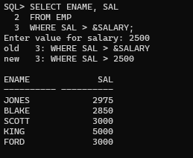

- Display employees who do not have a manager.

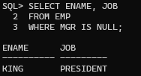

- Prompt for Manager ID and sort column.

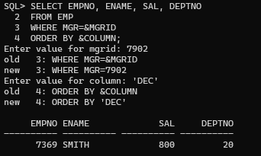

- Prompt for manager and display employees.

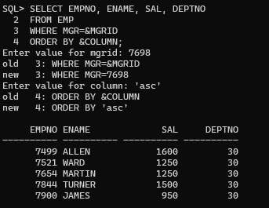
- Display employees whose third letter is A.

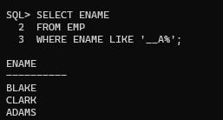

- Display employees having both A and S.

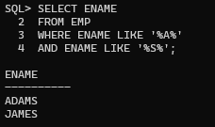

- Display Clerks with salary 800, 950 or 1300.

